The CLIMAVORE: Oyster Table
Access guide
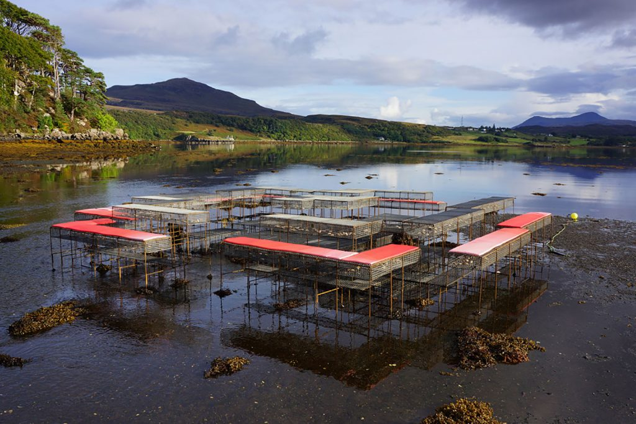Image showing The Oyster Table at low tide surrounded by seaweed and with red cushions on the seating.

About The Oyster Table:
The CLIMAVORE Oyster Table is an outdoor gathering space situated on the tidal zone of Bayfield in Portree. It is a metal caged structure containing mussels, oysters and seaweeds, where at low tide, we host events and talks.
It is only accessible to humans at low tide. If you visit at high tide, the table is submerged in water, marked by 4 floating buoys showing the structure’s position.
The tidal zone by its nature is wet, sandy and rocky and so consideration should be taken when visiting - this guide provides lots of information to help you to enjoy your visit.
Comfort:
The table itself is arranged as a series of benches andhigh tables. These are made from metal caged material. It is home to a variety of seaweeds, therefore, it can be slippery and caution should be taken when stepping on and off the structure. During events ATLAS provides special cushions for the benches to protect clothes and add comfort. We also provide umbrellas, and blankets for warmth.

Parking:
Free parking is available right next to the water at Lisigarry Crescent. Additional Short Stay paid parking at Somerled Square, Portree.
For further information on nearby parking, toilets and other helpful access information Skye for All have produced a really helpful Portree accessibility map. A downloadable and printable version can be found here.
Finding The Oyster Table:
Make your way to the Prince of India restaurant next to Lisigarry Crescent Free Parking. The slipway to the shore is easy to find from here. The 200m traverse to the table from the slipway is over an uneven and sometimes slippy shoreline. From the restaurant head along Bayfield Road towards the water, and turn onto the pebbled shore

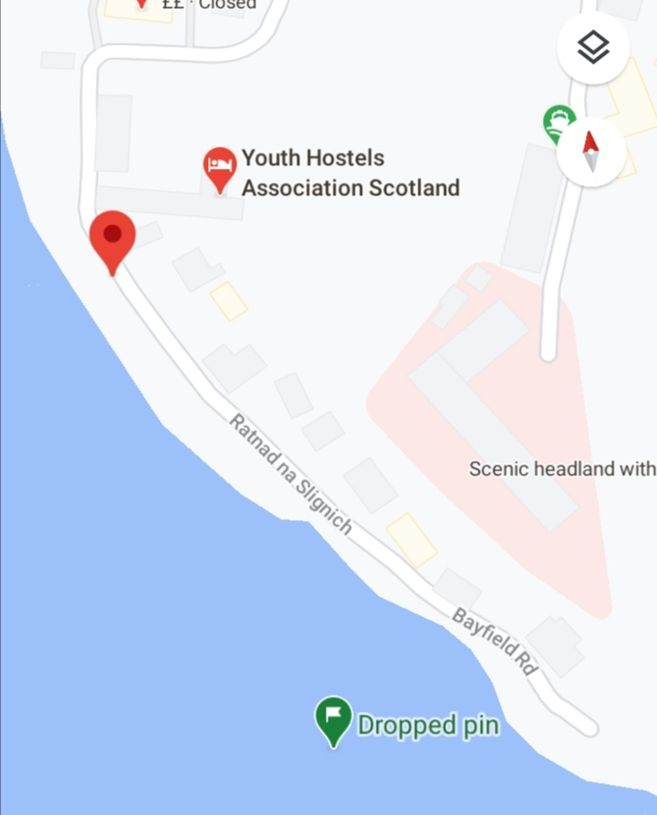 | 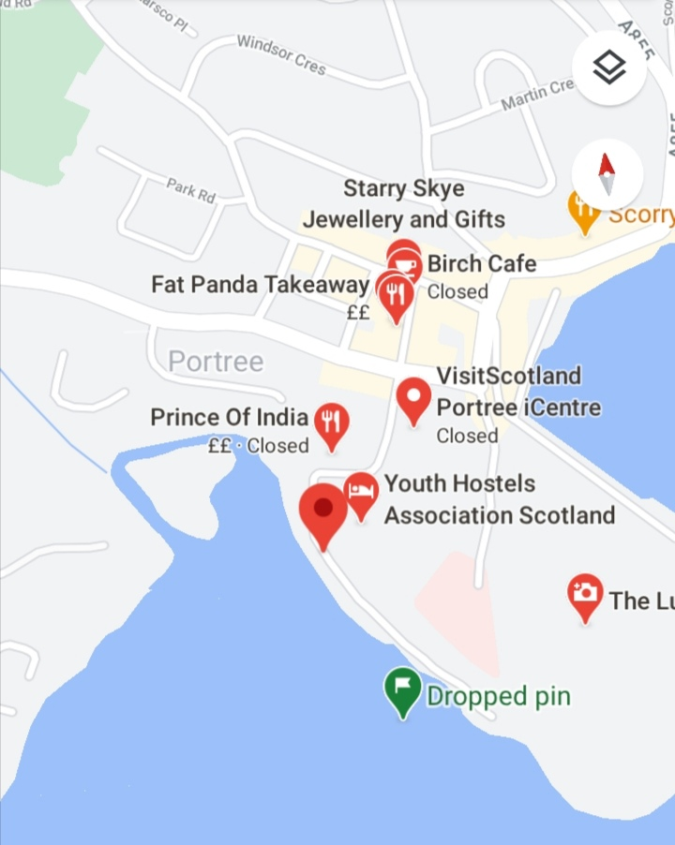
Green Dropped pin shows location of the Oyster Table Red pin shows location of the slipway

The road and slipway where you can access the shore: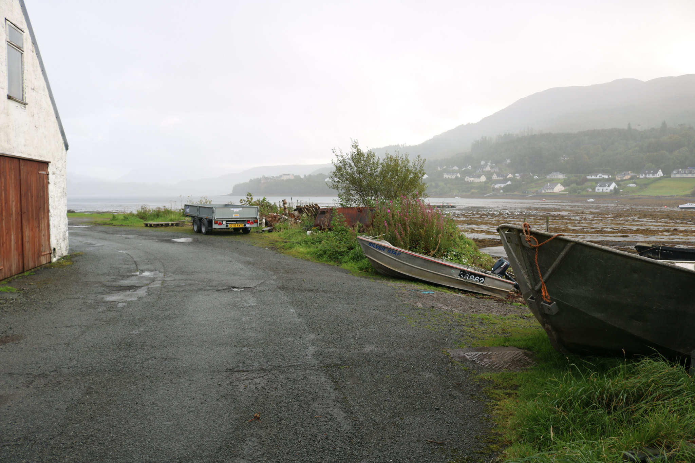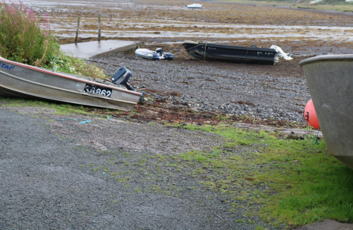

Weather:
Events will not go ahead in treacherous weather conditions such as high wind, high tides or heavy rain - and we’ll plan for alternative events venues just in case. Skye’s weather is changeable and if visiting we recommend planning ahead, checking tide times, weather reports and wearing suitable clothes and footwear such as wellies. ATLAS events will always take place at low tide.
Public Transport: Both Stagecoach and Citylink serve Portree, with links from most other parts of the Island and the mainland. Busses are not frequent so planning ahead is strongly advised.
The nearest bus stop to the Oyster Table is in Somerled Square, approximately 500m away.
Tip: Calling the Portree Stagecoach office directly is sometimes the best way to get info
tel: 01478 613 671 / Citylinks main line is 0141 352 4444

Please note that due to Covid-19 many of the school services normally accessible are, for the moment, closed to members of the public.

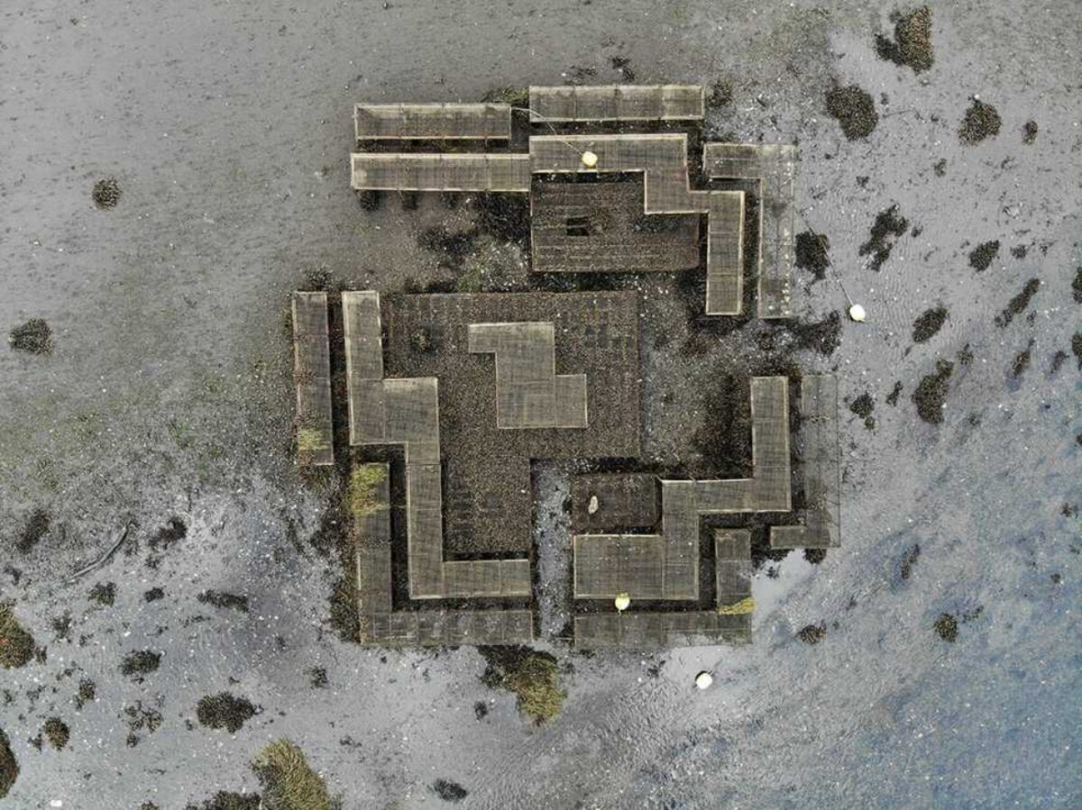The Oyster Table from above, at low-tide.

Additional info:
- There is good mobile phone signal at the table on most networks
- You can find the tide-times on our homepage - but please let ATLAS know if you are visiting The Oyster Table.
- ATLAS would like as many people as possible to be able to enjoy the Oyster Table in the safest possible way and we welcome feedback and ideas on how we can help.
- Please get in touch with admin@atlasarts.org.uk or phone 07805449820 if you would like to know more or if we can provide access information in another format.
- Covid-19 note: During these different days we ask that people observe physical distancing when visiting the Oyster Table.

